Lorenzo Dow “L. D.” Colaw
Abt. 1857 – February 12, 1916

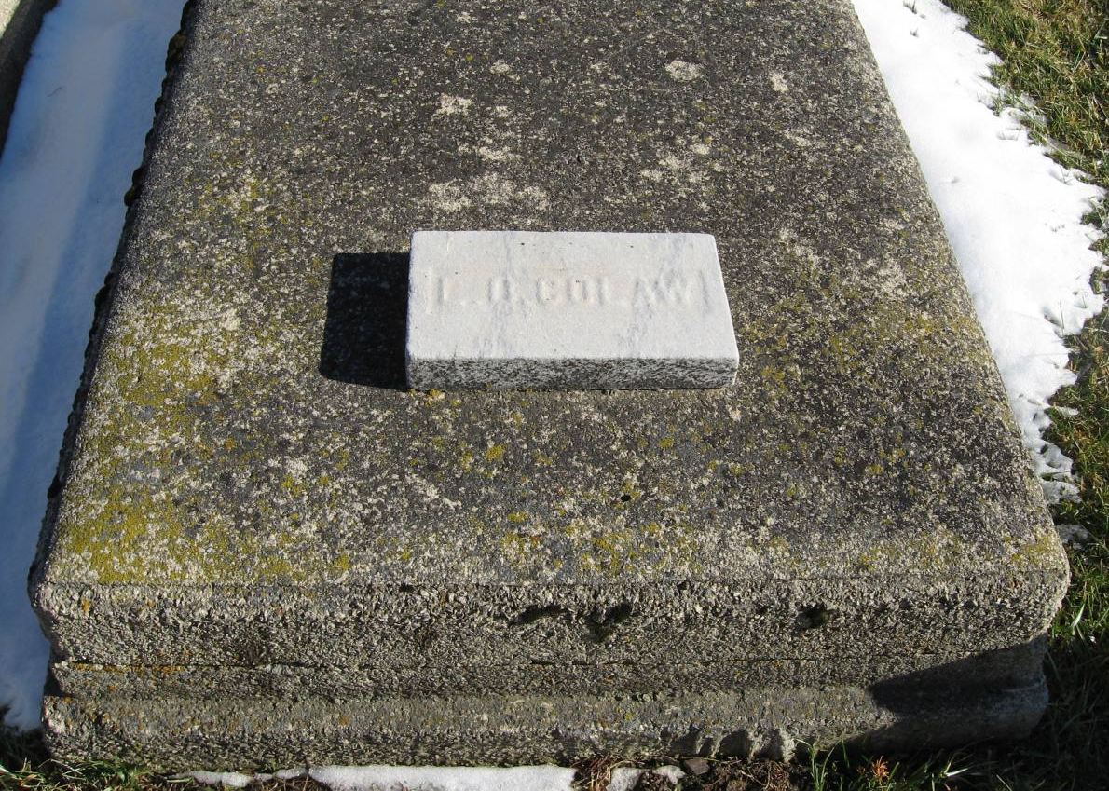
Photo by Tombstoner & Family

Indiana, WPA Death Index, 1882-1920

Name: Lorenzo D. Colow
Date: 12 Feb 1916
Location: Wells County
Age: 59 Yr
Gender: Male
Race: White
Source Location: County Health Office, Bluffton
Source Notes: The source of this record is the book H-18 on page 90 within the series produced by the Indiana Works Progress Administration.

