Mildred (Stultz) Biberstine
July 5, 1924 – December 6, 1999

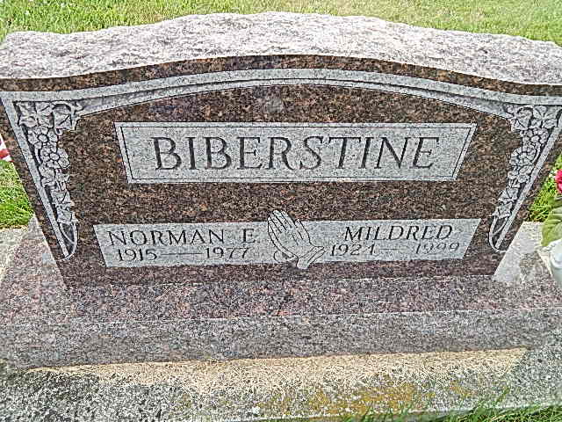
Photo by Tombstoner & Family

Mildred Biberstine Decatur - 1924-1999
Mildred Biberstine, 75, of Decatur, a native of Rockford, Ohio, died Monday, Dec. 6, 1999, at home. She had worked for Best Western in Fort Wayne for many years as a housekeeper, was a homemaker and a member of Decatur United Brethren Church and its Women's Missionary Fellowship. Surviving are daughters Donna Maples of Fort Wayne and Sharon Davis of Rockford, Ohio; stepsons Stephen and Norman, both of Fort Wayne; a stepdaughter, Sharon Trimm of Fort Wayne; five grandchildren; several stepgrandchildren; and one great-grandchild. She was preceded in death by her first husband, Donald D. Longsworth, her second husband, Norman M. Biberstine, two brothers and a sister. Services are 1 p.m. Thursday at Zwick & Jahn Funeral Home, Decatur, with calling one hour before services and also from 4 to 8 p.m. Wednesday. Burial will be in Evangelical Mennonite Church, Berne. Memorials are to Adams County Heart and the church. Information provided by Zwick & Jahn Funeral Home, Decatur, 1-219-724-9164.
News-Sentinel, The (Fort Wayne, Allen County, IN)
Tuesday, December 7, 1999
Contributed by Jane Edson

