Andrew Ernest Biberstine
March 5, 1907 – November 17, 1959

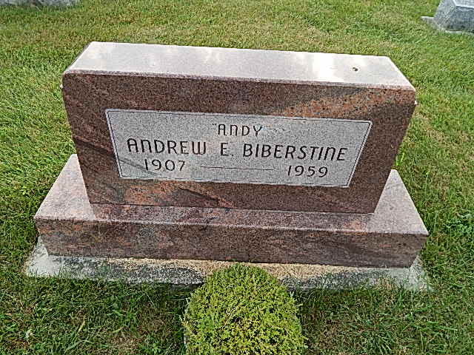
Photo by Alicia Kneuss

Indiana, Death Certificates, 1899-2011

Name: Andrew Ernest Biberstine
Gender: Male
Race: White
Age: 52
Marital status: Divorced
Birth Date: 5 Mar 1907
Birth Place: Adams Co. Ind.
Death Date: 17 Nov 1959
Death Place: Bluffton, Wells, Indiana, USA
Father: David Biberstine
Mother: Mary Moser
Informant: Crane Biberstine, son
Burial: 11/19/1959; Evang Mennonite Church Cem.

