Rev. Daniel Augsburger
August 27, 1880 – May 21, 1950

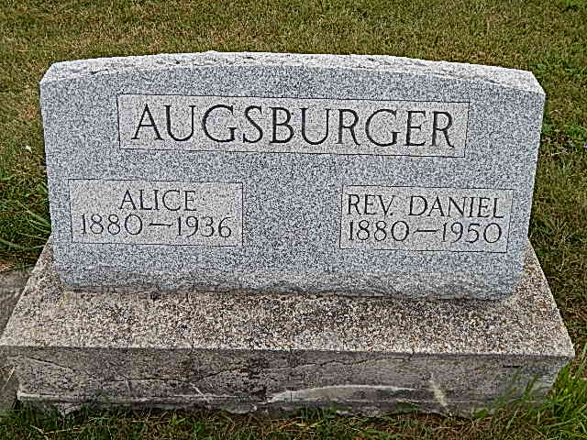
Photo by Alicia Kneuss

(Handwritten date: Monday, May 22, 1950)

DANIEL AUGSBURGER, 69, DIES ON SUNDAY
Funeral Here Wednesday For Native of Community; Sudden Death

Rev. Daniel Augsburger, 69, of Elida, Ohio, route 2, a native and for many years a resident of this community, died suddenly and unexpectedly at 1:00 p.m. Sunday at Memorial Hospital, Lima, Ohio. Death was apparently caused by a heart attack, following major surgery last Wednesday in the same hospital.
Rev. Augsburger, who was employed in a foundry at Lima, had worked until just the day before his operation. He was apparently recovering nicely. He was up and around in the hospital Sunday morning and was found by a nurse about 20 minutes before his death. He had apparently been sitting on a chair, suffering the attack and fell to the floor. He was put to bed but died soon afterwards.
His two brothers from here, John C. and Moses Augsburger, had left here Sunday morning to visit him in the hospital in the afternoon. They were dinner guests of their sister, Mrs. Fanny Hales, of route 2, Elida, where Rev. Augsburger made his home. While eating dinner they had a call from the hospital that he had been stricken. He had died before they arrived at the hospital.
Rev. Augsburger was born in French township, on the farm where Moses and Menno Augsburger now reside, August 27, 1880, the son of Rev. Christian and Barbara Liechty Augsburger. He was married at Linn Grove in 1903 to Alice Stauffer, who preceded in death July 21, 1936.
Rev. Augsburger was a farmer and laborer for many years. He was ordained as a minister on October 22, 1922, in the ?? by the late Bishop J. M. Shenk. Rev. Augsburger was a supply pastor in different churches. He filled local pulpits on numerous occasions and also spoke in many churches in Ohio. He visited missions and rescue homes and devoted much of his time to the ministry and the spreading of the gospel. He moved from here to Ohio 22 years ago.
Surviving are two brothers, Moses and John C., both of this community, and a sister, Mrs. Fanny Hales, of near Elida, Ohio. The widow, three children who died in infancy and the following (cut) Mrs. John Kauffman, Mrs. Jacob Greider , Mrs. Jacob M. Neuenschwander, Mrs. Oscar Burry and four in infancy. Rev. Augsburger was the youngest of a family of 16 children. (Cut off)

Adams County Historical Museum
1933-1953 Scrapbook, Image 016
Transcribed by Karin King

