Rev. Christian Augsburger
June 21, 1921 – January 19, 1903

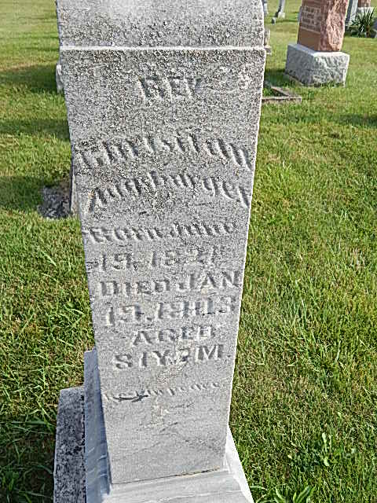
Photo by Alicia Kneuss
PASSED AWAY
Rev. Christian Augsburger of Berne is Dead
Rev. Christian Augsburger, of Berne, died at his home Monday night. Mr. Augsburger was quite an aged man, and the direct cause of his death was a fall which he received some time ago. No serious results were expected at the time of the accident, as the only apparent injury was a bruise on the hip, but he seemed to grow gradually worse until death came. His funeral services will be held tomorrow morning at ten o'clock.
Decatur Daily Democrat, Adams County, Indiana
Wednesday, January 21, 1903
*****
Indiana, Death Certificates, 1899-2011
Name: Christian Augsburger
Gender: Male
Race: White
Age: 81
Marital status: Married
Birth Date: 21 Jun 1821
Birth Place: Pennsylvania
Death Date: 19 Jan 1903
Death Place: French Tp., Adams, Indiana , USA
Father: John Augsburger
Mother: Elizabeth Jacobs
Spouse: Barbara
Burial: Jan. 22, 1903; D F M Cem.

