Christian A. Amstutz
March 17, 1832 – February 4, 1891

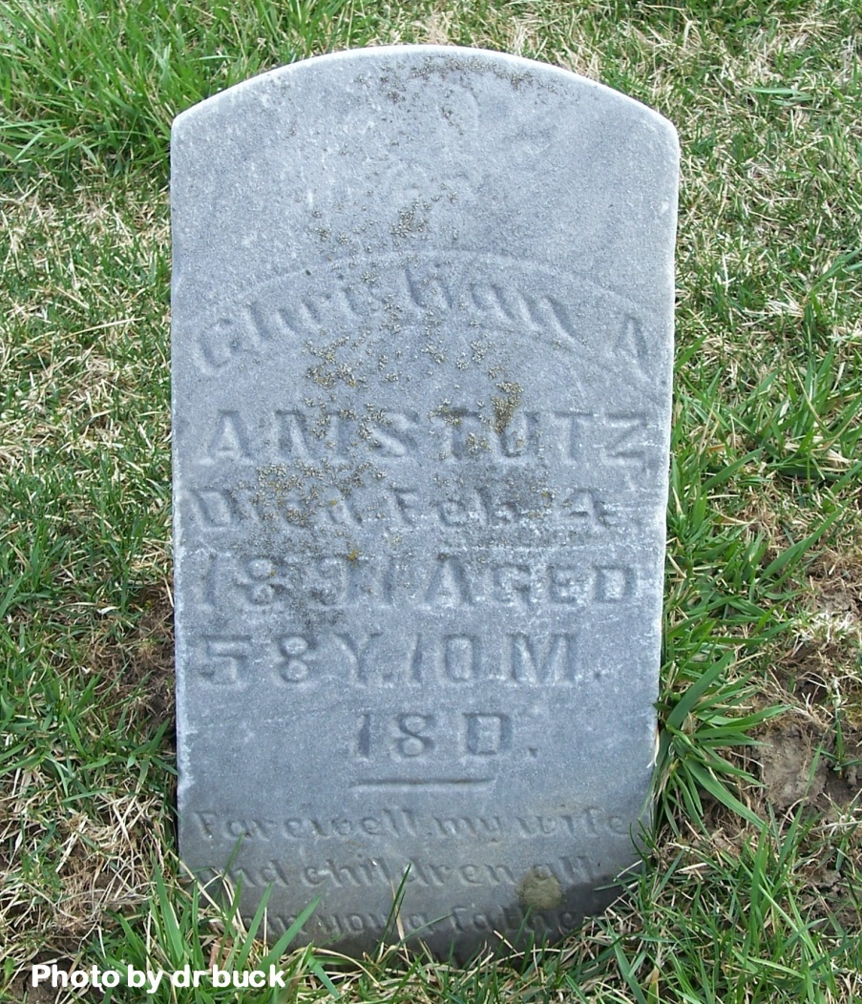

Christian A. Amstutz, who lately returned from the insane hospital at Richmond, died at his home in French township, on Thursday of last week.

Decatur Democrat, Adams County, Indiana (a weekly newspaper)
Friday, Feb. 13, 1891

