Charles E. Allison
August 3, 1925 – January 22, 2015

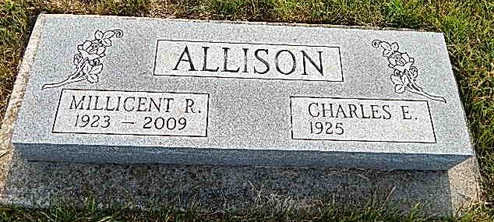
Photo by Alicia Kneuss

Charles E. Allison

He was the son of Martin and Elizabeth (Horst) Allison. Growing up he lived in Peabody, Kan., Palmyra, Mo., Maple Park, Mo., and Kansas City, Kan.
Due to World War II, after completing the 11th grade, Charles stopped attending high school but in 1946 moved to Hesston, Kan., to complete his senior year of high school through a program offered by Hesston College. He graduated in 1947. After high school, he moved to Gulfport, Miss., to do work under the authority of the Mennonite Central Committee (MCC) where he worked in maintenance at an MCC camp. It was here that he met his wife of 56 years, Millie (Litwiller) Allison. The two were married in Berne, Ind., on June 7, 1952. After their marriage, the couple lived in Kansas City, Kan., for about a year and then moved to Berne, Ind., until 1970. At this time Charles and Millie moved to Anderson, where they lived in the same house for 36 years Charles was a man of his hands. Throughout his life he held a variety of jobs, including that of an auto mechanic, furniture maker (Berne, Ind.), farmhand, home dairy route driver, lumberyard manager and barn builder. Singer Sewing Machine brought him to Anderson where he managed one of its stores. From there he worked at Montgomery Ward. His last job before he retired was custodian at West Central Community Schools (Frankton Elementary and Leach Elementary and Junior High). He retired in 1997.
In addition to these jobs, Charles used his carpentry and mechanical skills to help many people. While his physical body allowed him, he was always building or repairing a piece of furniture, doing home maintenance, servicing a car, or fixing a sewing machine.
Charles was also a longtime member of West Cross Street Alliance Church. He used many of the same skills listed above to help the church that he loved. In his later years the people of this pleasure in regular attendance.
Charles is survived by his sons, Brian (wife, Catherine) of Fishers, and Mike Allison (whereabouts unknown); daughter, Susan (Allison) Geller; grandchildren, Candice Hammel of Seattle, Wash., Evonne Hammel of Indianapolis, Ashlan Allison of Boston, Mass., Stevie Chapman of Fortville, and Darcie Hargis of Deerfield Beach, Fla.; sistersin-law, Delores Moorman of Warsaw, Juanita Adams (husband, Jim) of Berne, and Marilyn Litwiller of Berne; and brothers-inlaw, Darrel Thieszen of Henderson, Neb., and Bob Mehberger of Tuscon, Ariz.
Charles was preceded in death by his wife, Millie Allison; parents, Martin and Elizabeth (Horst) Allison; brothers, Vernon (wife, Dorothy) Allison, William Allison, and Martin Allison; sisters, Ruth Allison, Emma Bridegroom and Alma Shannon; brothers-in-law, Robert Litwiller, Jack Moorman and Forest Felger; and sisters- in-law, Dorothy Allison, Marjorie Felger, Verna Thieszen and Romayne Meshberger.
Visitation will be held from 4 to 8 p.m. Monday at Robert D. Loose Funeral Homes & Crematory, 200 W. 53rd St., Anderson. Services will be at 10 a.m. Tuesday at the funeral home with the Rev. Bob Brown officiating. Burial will take place at 1 p.m. at the Berne Evangelical Church Cemetery, Berne.
The family would like to thank the wonderful and caring staff at United Faith Housing’s Vermillion Place located in Anderson. Charles happily lived there for the last seven years of his life. The family also extends its thanks to the staff at Countryside Manor for their recent care of Charles.
Memorial contributions may be made to West Cross Street Alliance Church, 3102 W. Cross St., Anderson, IN 46011; Child Evangelism Fellowship, 1445 W. Hoosier Blvd., Suite 101, Peru, IN 46970; Mission Aviation Fellowship, P.O. Box 47, Nampa, ID 83653, www.maf.org; Campus Crusade for Christ, P.O. Box 628222, Orlando, FL; or Youth Serving Christ, P.O. Box 123, Anderson, IN.

Contributed by Family Matters & Lynn Stoops Chapel – no source listed

