Beatrice M. (Lautzenheiser) Wendel
August 5, 1919 – August 6, 1975

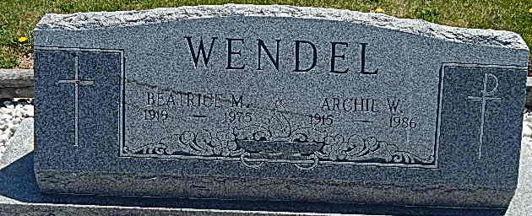
Photo by Alicia Kneuss

Beatrice M. Wendel, 56, 703 Elm Street, wife of Archie Wendel, died at 3:14 p.m. Wednesday at the Lutheran Hospital in Fort Wayne. She had open heart surgery on June 4 and had been hospitalized for the past two day. Born in Mercer County, O., on August 5, 1919, she was the daughter of Sidney and Ethel Detro-Lautzenheiser and was married on December 21, 1940 to Archie Wendel, who is employed by the city of Decatur.
Survivors include the husband; three daughters, Mrs. Jack (Arlene) Sprunger, Decatur; Mrs. Javier (Rita) Cuellar, Winchester, and Donna, at home; one son, Kenneth, at home; two sisters, Mrs. Harold (Edna Mae) Shoaf, route 6, and Miss Wanda Lautzenheiser, St. Petersburg, Fla.; five brothers, Cleo, Wren, O.; Eldon, Celina O.; Gerald, route 1, Rockford, O.; Donald, Berne, and Robert, route 2, Geneva, and three granddaughters.
Funeral services will be held at 1:30 p.m. Saturday at the Zwick Funeral Home with Rev. Richard Kirk officiating. Burial will be in the Mount Hope Cemetery. Friends may call at the funeral home after 11 a.m. Friday.

Decatur Daily Democrat, Adams County, IN
Thursday, August 7, 1976

