Jessie E. Sipe
July 29, 1887 – May 16, 1975

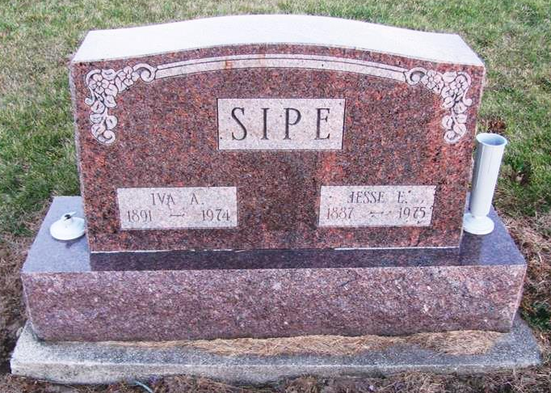
Photo by Jenna Langdon
WILLSHIRE - Jesse E. Sipe, 87, of Rt. 1, Willshire died at 6:35 a.m. (EST) today at Glenacres Nursing Home in Fort Wayne, after an extended illness. Born July 29, 1887, in Black Creek Township, Mercer County, he was the son of John A. and Valera (Frank) Sipe. On March 5, 1911, he married the former Iva Harker, who preceded him in death in 1974. Survivors include two grandsons and a granddaughter. Mr. Sipe was preceded in death by a son and a daughter. He was a farmer until his retirement. Funeral services will be held at 1:30 p.m. (EST) Sunday in Zwick Funeral Home, Decatur, the Rev. Robert James officiating. Burial will be in Mt. Hope Cemetery, southeast of Decatur. Friends may call after 2 p.m. (EST) Saturday at the funeral home.
Times Bulletin, Van Wert County, Ohio; May 16, 1975
Contributed by Karin King
*****
Jesse E. Sipe, 87, of route 1, Willshire, O., a retired farmer, died at 6:35 a.m. this morning at the Glenacres nursing home, Fort Wayne, where he had resided since last October.
Born in Mercer county, O., on July 29, 1887, he was the son of John H. and Valeria Frank-Sipe, and was united in marriage on March 5, 1911 to Iva Harker, who died June 4, 1974.
Survivors include one granddaughter, Mrs. Bonnie Walowich of Fort Wayne; two grandsons, Robert Sipe of Springfield. Ill., and David Sipe of Chicago, Ill.; and seven great-grandchildren.
One daughter, Vauneda, died May 4, 1974, and one son, Bud, died in 1956.
Funeral services will be held at 1:30 p.m. (Indiana time) Sunday at the Zwick funeral home, with Rev. Robert James officiating. Burial will be in the Mt. Hope cemetery. Friends may call at the funeral home after 2 p.m. Saturday.

Decatur Daily Democrat, Adams County, IN Friday, May 16, 1975
Contributed by Janice Vasilovski
*****
Indiana, Death Certificates, 1899-2011
Name: Jesse Earl Sipe
Gender: Male; Race: Caucasian (White); Age: 87; Marital Status: Widowed
Birth Date: 29 Jul 1887; Birth Place: Ohio
Death Date: 16 May 1975; Death Place: Ft Wayne, Allen, Indiana, USA
Father: John H. Sipe; Mother: Valera Frank; Informant: Clark Sipe of Rockford OH,
Burial: 5/18/1975, Mt. Hope Cemetery, Berne

