Harvey L. Sipe
December 28, 1885 – August 16, 1943
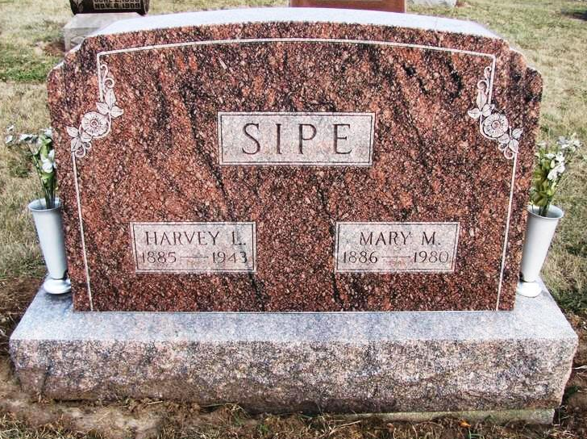
Photo by Jenna Langdon

(Handwritten date: Monday, August 16, 1943
Harvey L. Sipe, 58, Prominent Farmer Dies Today
Former Blue Creek Township Trustee Dies after Operation; Rites Wed. P.M.
Harvey L. Sipe, 58, well-known farmer of Blue Creek Township and former trustee of that township, died this evening at the Adams County Memorial Hospital where last Tuesday he submitted to an appendectomy. Because of a diabetic condition, he was regarded as a poor operative risk; however, there was no alternative when a week ago this evening he was hit with an acute attacks of appendicitis. He was apparently progressing alright, but the process of the diabetic condition eventually threatened his recovery and early this morning he drifted away into a diabetic coma.
The community was greatly shocked today with the report of his passing as he had prominent in the activities of the community and was well-known. Mr. Sipe served as Trustee of Blue Creek Township.
Mr. Sipe was the son of Andrew and Catherine Sipe and was born on December 28, 1885, in Blue Creek Township, having lived his entire life in that township. He was married at Decatur on January 31, 1913 to Miss Mary M. Kelly, who survives with the following children: Earl and Lewis of Blue Creek Township; Miss Maryann of Fort Wayne and Robert, at home. There are also five grandchildren.
His parents and his only brother, William Sipe, preceded him.
Funeral services will be held Wednesday afternoon at 8 o’clock at the Mt. Hope Church of the Nazarene, preceded by a short service at the home. Rev. W. F. Johnson will officiate and will be assisted by Rev. Priddy. Burial will be in Mt. Hope Cemetery.

Adams County (IN) Historical Museum
1943B Scrapbook, image 90
Transcribed by Karin King

