Catherine (Fallen) Sipe
March 1, 1848 – April 9, 1911

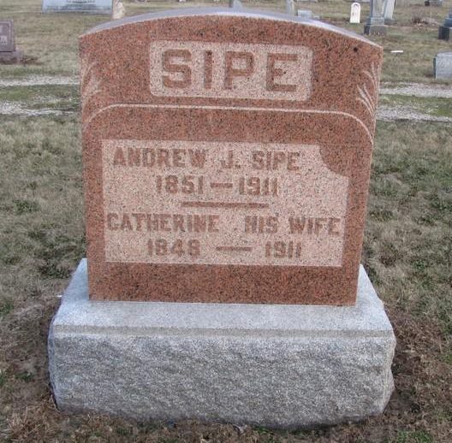
Photo by Jenna Langston

MRS. ABIJAH SIPE
Mrs. Abijah Sipe (nee Catharina Fallen) was born in Dark county, Ohio, March 1, 1848. On January 15, 1874, at the age of 22, she was married to Abijah Sipe, brother of Louis Sipe living here in town. They lived on a farm 5 miles east of Berne where they worked ad labored together for 37 years and had gained for themselves a comfortable living. In the meantime two sons Wm. A. and Harvey were born to this union. On the second day of last month they moved to Berne in the property on East Water street which they purchased of Wm. Waggoner, their son William moving onto the old homestead.
Mrs. Sipe had been sick with the grip more or less all winter but it was only last Friday that she took very sick with pneumonia and became unconscious in the evening, never regaining consciousness to the time of her death which occurred yesterday forenoon after only two days of severe sickness.
The sorrowing ones whom she leaves are her husband, two sons, three grandchildren and many other relatives.
Funeral will be held tomorrow at 12:30 from the house and at the Mount Hope church east of town, Rev. Kohn, of Willshire officiating.

Berne Witness, Adams County, IN; Monday, April 10, 1911

Contributed by Karin King

