Andrew J. Sipe
January 22, 1851 – December 6, 1911
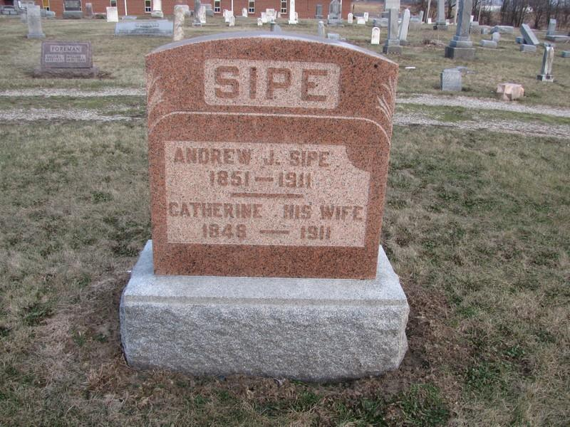
Photo by Jenna Langston
Andrew J. Sipe died Wednesday, Dec. 6, at Indianapolis where he had underwent an operation. Funeral this afternoon at 1:00 o'clock at his residence, 5 1/2 miles east of town and 2:00 at the Mt. Hope church.
Berne Witness, Adams County, Indiana; Friday, Dec. 8, 1911
Contributed by Karin King
*****
Obituary of A. J. Sipe
A.J. Sipe was born in Butler county, Ohio, Jan. 22. 1851. He departed this life in Indianapolis, Ind., Dec. 6, 1911, aged 60 years, 10 month and 14 days.
He came to Adams county, Ind., with his parents when 3 years old and has been a resident of this county since.
Jan. 15, 1874 he united in marriage with Catherine Fallen and to this union were born two children William A. and Harvey L. Sipe, both residents of Blue Creek township.
His wife preceded him in death just 7 mo. and 27 days [sic].
Besides the two sons he leaves two brothers, four grandchildren and a host of other relatives and friends to mourn their loss.
Funeral was conducted at the Mount Hope church by Rev. D. A. Kaley, of Berne, Friday afternoon, and burial near by.
CARD OF THANKS
The undersigned hereby wish to express their heartfelt thanks to all neighbors and friends who so kindly gave aid during the sickness and burial of our father.
Wm. and Harvey Sipe (no date)

Berne (IN) Library Heritage Room
More Misc. Obits
Transcribed by Janice Vasilovski

