William Kauffman
December 6, 1894 – February 5, 1974

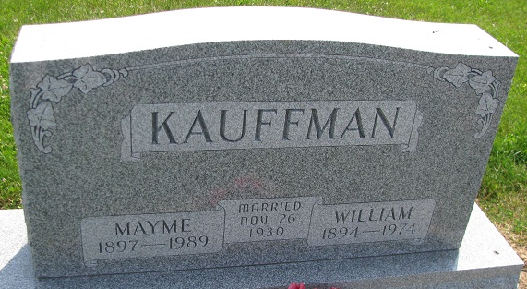
Photo by PLS

William Kauffman Dies at Hospital
William Kauffman, 79, of route 2, Berne, a retired farmer, died at 2:50 a.m. today at the Adams County Memorial Hospital, where he had been a patient three weeks. He was a member of the Mt. Hope Church of the Nazarene and a veteran of World War I.
Born in Monroe Township on Dec. 6, 1894, he was a son of Jacob and Rosina Myer-Kauffman, and was married on Nov. 26, 1930, in Decatur, to Mayme Foreman, who survives.
Other survivors include one daughter, Mrs. Harry (Julia Ann) Mazelin of route 2, Berne; one brother, Daniel of Decatur; four sisters, Mrs. Arman (Rose) Hirschy of Fort Wayne; Mrs. Herbert (Lillian) Burdge of rural route, Bluffton; Mrs. Ida Flueckinger and Mrs. Leona Farlow, both of Berne, and three grandchildren. Two brothers preceded him in death.
Funeral services will be held at 2 p.m. Thursday at the Mt. Hope Church of Nazarene, with Rev. Robert E. James officiating. Burial will be in the Mt. Hope Cemetery. Friends may call at the Yager Funeral Home after 2 p.m. Wednesday and until 12 noon Thursday, and then after 1 p.m. at the church.

Decatur Daily Democrat, Adams County, Indiana
Tuesday, February 5, 1974

