Jacob Wechter
September 18, 1831 – July 14, 1920

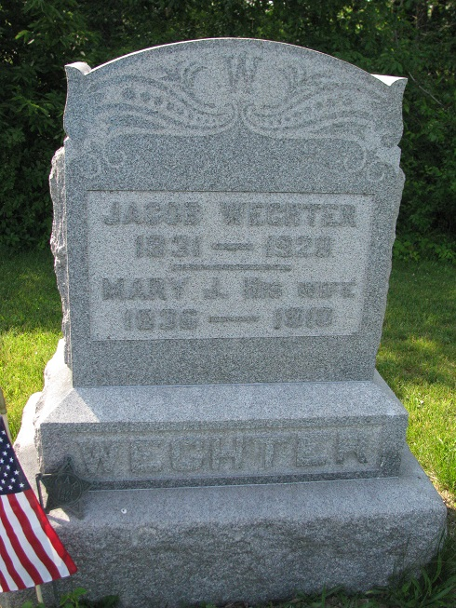
Photo by PLS

ANOTHER VETERAN CALLED

Willshire, O., July 16 – Jacob Wechter, aged 88, a Civil War veteran, died Wednesday afternoon at the home of his son, John. He came to Willshire from Rochester, N.Y. in 1871, bought a farm south of town, and has lived there continuously with the exception of ten months.
He was an active member of the Methodist Church.
Funeral services will be held from the M. E. Church at 10 o’clock tomorrow morning with interment at the Tricker Cemetery.

Fort Wayne News-Sentinel (IN); July 16, 1920
*****
Indiana, Death Certificates, 1899-2011
Name: Jacob Wechter
Gender: Male; Race: White; Age: 88; Marital Status: Widowed
Birth Date: 18 Sep 1831; Birth Place: New York
Death Date: 14 Jul 1920; Death Place: Blue Creek, Adams, Indiana
Father: George Wechter; Mother: Francis Welch; Spouse: Mary Wechter
Informant: John Wechter
Burial: 7/17/1920, Tricker Cemetery

Contributed by Karin King

