Leona M (Bartling) Teeple
November 5, 1898 – May 31, 1982
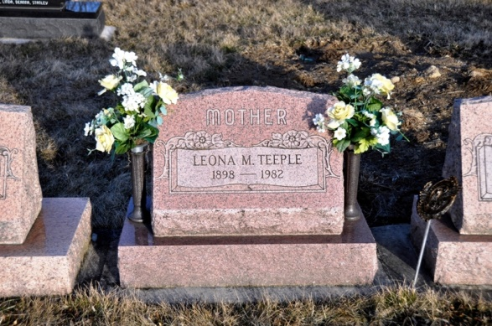
Photo by Deb Curry

Leona M. Teeple, 83, Fort Wayne, a native of Blue Creek Township, died unexpected at her residence. [5/31/1982] She was a former member of the Salem United Methodist Church. Born in Adams County on Nov. 5, 1898, she was the daughter of Oscar and Jessie DeArmond-Bartling. Survivors include nine children, Mrs. William (Jessie) Grepke, Mrs. James (Patricia) Marks, Mrs. Gerrie Lauck, Albert J. Teeple, all of Fort Wayne; Robert M. Teeple, Decatur; D. Wayne Teeple, Rt. 1, Decatur; Mrs. Walter (Zella) Haines, Rt. 2, Decatur; Mrs. Ora (Esther) Adams, Berne; Raymond D. Teeple, Craigville; two half-sisters, Mrs. Keith (Mary) Erwin, Fort Wayne; Mrs. Elmer (Bea) Young, San Diego, Calif.; two halfbrothers, Harry Davis and Charles Davis, both of Fort Wayne; 30 grandchildren; and 30 great-grandchildren. One son, Richard, died during World War II on Aug. 9, 1944, and one brother also preceded her in death. Funeral services will be held Thursday at 10 a.m. at the Zwick, Boltz & Jahn Funeral Home, with Rev. Robert Schreffler officiating. Burial will be in the Tricker Cemetery. Friends may call at the funeral home after 2 p.m. Wednesday. Preferred memorials are to the Heart Fund.
Decatur Daily Democrat, Adams Co, IN; Tuesday, 1 June 1982

