Merle William Riley
February 1, 1908 – February 28, 1987

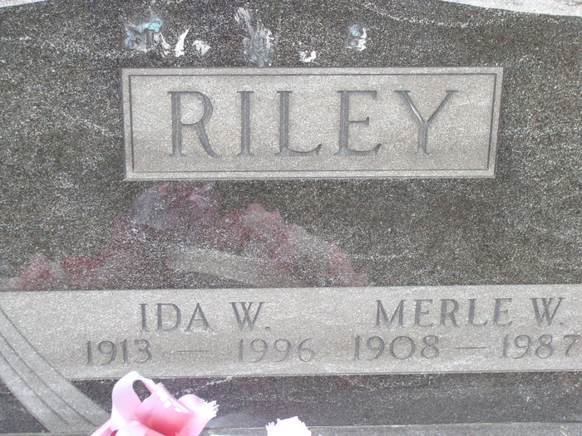
Photo by Alicia Kneuss

Merle W. RILEY, 79, route 1, Monroe, lifelong resident of Blue Creek Township, died Saturday at 1:10 p.m. at Adams County Memorial Hospital. Seriously ill 10 weeks, he was hospitalized Thursday.
The retired Blue Creek Township farmer also retired from Decatur General Electric Co., in 1971 following 29 years of service. He was a member of the Adams County Historical Society and the Quarter Century Club of the GE.
Born 1 February 1908, in Adams Co., he was the son of Albert and Clara DAVIS-RILEY, and was married to Ida W. GIROD on 28 July 1934, in Adams County; she survives. Also surviving are three sons, Steven B. RILEY, Gale N. RILEY, and Norman F. RILEY, all of route 1, Monroe; two sisters Mrs. Glenn (Wilda) RUPERT, Monroe; Mrs. William (Ruth) BROWN, Decatur; one brother, Norris RILEY, of near Rockford, Ohio; and four grandchildren. Seven brothers are deceased; Rev. Vernon, Nolan, Reed, Dale, True, Alton, and Wilmer.
Services will be held at 1:30 p.m. Tuesday at Zwick-Boltz & John Funeral Home, Rev. Jeffery SIMMONS officiting. Burial will be in Tricker Cemetery. Calling is from 2-9 p.m. today.
Memorials are to the Adams County Home Health Care.
Obit Book # 7, Page 12, Col. 3, Decatur Library, Adams Co., IN, 2 March 1987

Contributed by Sharon Schaffner
*****
Merle W. Riley, 79, died at 1:10 pm Saturday in Adams County Memorial Hospital, Decatur.
Surviving are his wife, Ida W.; three sons, Steven B., Gale N. and Norman F., all of Monroe; two sisters, one brother and four grandchildren.
Services at 1:30 pm Tuesday in Zwick-Boltz & Jahn Funeral Home, Decatur, with calling from 7 to 9 pm today and 2 to 9 pm Monday.
Memorials to Adams County Home Health Care.

Fort Wayne Journal-Gazette (IN); March 1, 1987, Page 4C

Contributed by Karin King
*****
Indiana, Death Certificates, 1899-2011
Name: Merle William Riley
Gender: Male; Race: White; Age: 79; Marital Status: Married
Birth Date: 1 Feb 1908; Birth Place: Indiana
Death Date: 28 Feb 1987; Death Place: Decatur, Adams, Indiana, USA
Father: Albert Riley; Mother: Clara Davis
Spouse: Ida Riley, informant
Burial: 3/3/1987, Tricker Cemetery

