Ida Wilma (Girod) Riley
April 2, 1913 – August 26, 1996

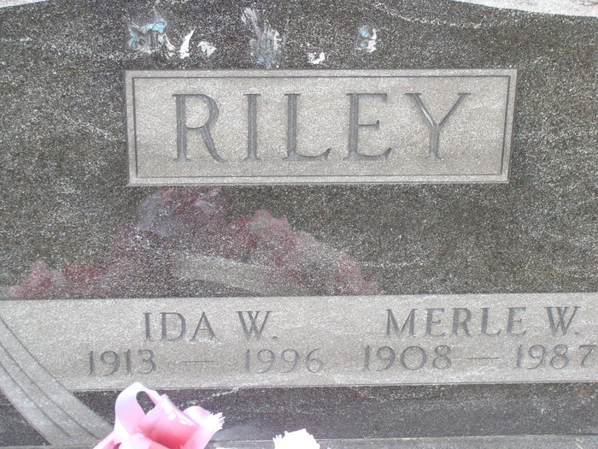
Photo by Alicia Kneuss

Ida Riley, 83, of rural Monroe died Monday in Adams County Memorial Hospital. The Geneva native was the widow of Merle W., who died in 1987.
Surviving are sons, Steven B. and Gale N., both of Monroe and Norman F. of Decatur; a sister, Dasie Smith of Fort Wayne; a brother, Ernest Girod of Decatur; four grandchildren; and two great-grandchildren.
Services are 10:30 am Thursday in Zwick-Sefton & Jahn Funeral Home, Decatur, where calling is 7 to 9 pm today and 2 to 5 and 7 to 9 pm Wednesday. Burial will be in Tricker Cemetery, Monroe.
Memorials are to Salem United Methodist Church or Adams County Home Health.

Fort Wayne News-Sentinel (IN); August 27, 1996, Page 4A
*****

Indiana, Death Certificates, 1899-2011 (very difficult to read)
Name: Ida Riley [Ida Girod]
Gender: Female; Race: White; Age: 83; Marital Status: Widowed
Birth Date: 2 Apr 1913; Birth Place: Geneva, Iti
Death Date: 26 Aug 1996; Death Place: Decatur, Adams, Indiana, USA
Father: August Girod; Mother: Cecil E Brunner
Informant: Gale N. Riley of Monroe, son
Burial: 8/29/1996, Tricker Cemetery

