Kenneth G. Riffle
November 21, 1945 – July 3, 1994

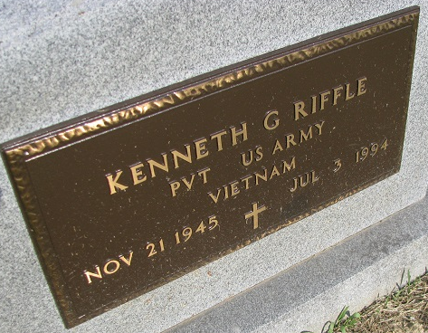
Photo by PLS

Kenneth G. Riffle, 48, of Decatur died Sunday at home. The Decatur native was a former employee of Fort Wayne Newspapers and veteran of the Vietnam War.
Surviving are his mother, Minerva Riffle of Decatur, and stepbrother, Roger Call of Monroe.
Services are 1 p.m. tomorrow in Zwick-Sefton & Jahn Funeral Home, Decatur, where calling is 6 to 8 p.m. today. Burial will be in Tricker Cemetery, Monroe.

Fort Wayne News-Sentinel (IN); Tuesday, July 5, 1994

Contributed by Jane Edson

