Harley W. Riff
June 17, 1913 – August 15, 1974

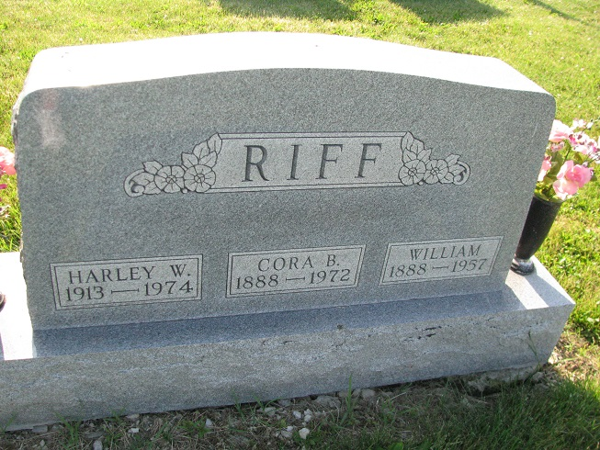
Photo by PLS

Harley W. Riff Dies Thursday
Harley W. Riff, 61, route 1, Geneva, a resident of Blue Creek Township most of his life, died at 12:35 p.m. Thursday at the Decatur Community Care Center, where he had been a patient since Feb. 26.
The son of William and Cora Young-Riff, he was born in Adams County June 17,1913.
Never married, his survivors include his sister, Mrs. Ben (Mary) Owens, with whom he made his home, and a brother, John, of Geneva. One brother is deceased.
Friends may call at the Zwick Funeral Home after 2 p.m. today.

Decatur Daily Democrat, Adams County, Indiana
Friday August 16 ,1974

