Frances D. (Ross) Nooner
March 8, 1908 – March 26, 1996

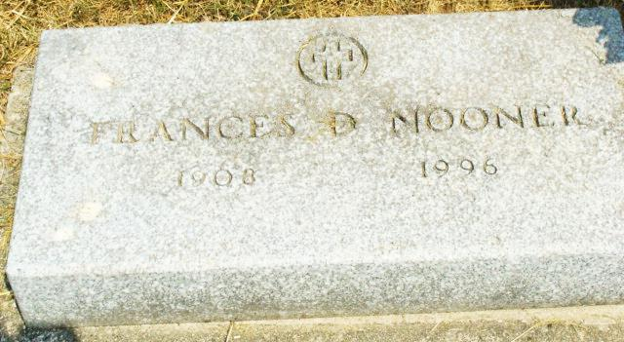
Photos by Alicia Kneuss

Frances D. Nooner, 88, of Decatur died Tuesday at Adams County Memorial Hospital.
Surviving are daughters, Barbara A. Burhart, Mary E. Mitchel and Vickie E. Yocum, all of Decatur, Nancy L. Watkins of Muncie, Delores J. Halas of Midland, Texas, and Margie L. Sarnold of Shanaloo, La.; a brother, William W. of Kodiak, Alaska; 20 grandchildren; 40 great-grandchildren and 22 great-great grandchildren.
Services are 1:30 pm Friday at Zwick-Sefton & Jahn Funeral Home, Decatur. Calling is from 2 to 8 pm Thursday at the funeral home. Burial will be in Tricker Cemetery, Monroe.

Fort Wayne News-Sentinel (IN); March 27, 1996, Page 8A

