Mary Edith (Teeple) Myers
August 19, 1883 – November 20, 1962
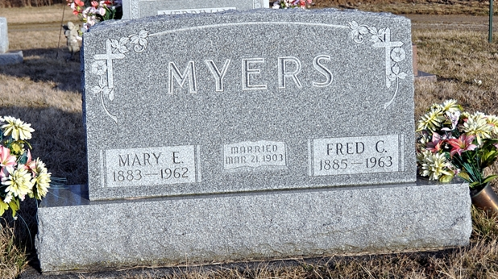
Photo by Deb Curry

Mrs. Fred C. Myers Is Taken By Death

Mrs. Mary E. Myers, 79, wife of Fred C. Myers of Blue Creek township, 1 1/4 miles southwest of Salem, died at 1:30 p.m. Tuesday at the Adams county memorial hospital, where she had been a patient for five months.
She was born in St. Mary's township Aug. 19, 1883, a daughter of Henry and Rebecca Miller-Teeple, and was married to Fred C. Myers March 21, 1903. They celebrated their 59th wedding anniversary last March. Mrs. Myers was a member of the Salem Methodist church.
Surviving in addition to her husband are four sons, Guy L. Myers of Louisville, Ky., John H. Myers of Mercer county, O., Frederick A. Myers of Blue Creek township, and James E. Myers of Decatur; four daughters, Mrs. Paul (Dellsen) Brehm, Mrs. Eli (Ruth Marie) Hirschy, and Mrs. Otis (Betty) Sprunger, all of Monroe township, and Mrs. Gerald (Mary Lou) Haggard of Monroe; 24 grandchildren; five great-grandchildren, and three brothers, John Teeple of Bellefontaine, O., Oscar Teeple of Blue Creek township, and Albert Teeple of Elida, O.
Funeral services will be conducted at 1:30 p.m. Friday at the Salem Methodist church, the Rev. Joseph Gibson officiating. Burial will be in the Tricker cemetery. Friends may call at the Zwick funeral home after 7 p.m. today. The body will lie in state at the church from 12:30 p.m. Friday until time of the services

Decatur Daily Democrat, Adams Co, IN; Wednesday, 21 November 1962
*****
Wife Of Frank C. Myers Dies On Tuesday - Funeral Friday For Blue Creek Tp. Woman

Mrs. Mary E. Myers, 79, wife of Frank C. Myers of Blue Creek township, died at 1:30 p.m. Tuesday at the Adams County Memorial hospital an illness of five months. Death was attributed to several strokes. The Myers home is 1 ¼ miles south west of Salem.
Mrs. Myers was born in St. Mary’s township August 19, 1883, the daughter of Henry and Rebecca Miller Teeple. She was married to Frank c. Myers March 21, 1903 and they had been married more that 59 years. She was a member of the Salem Methodist church.
Surviving are the husband; four sons, Guy L. Myers of Louisville, Ky.; John H., Mercer county, Ohio; Frederick A., Blue Creek township and James E. Decatur; four daughters, Mrs. Paul (Dellsen) Brehm, Mrs. Eli (Ruth Marie) Hirschy and Mrs. Otis (Betty) Sprunger, all of Monroe township and Mrs. Gerald (Mary Lou) Haggard, Monroe; 24 grandchildren and three brothers, John Bellfontaine, Ohio; Oscar, Blue Creek township and Albert, Elida, Ohio.
Services will be held at 1:30 p.m. Friday at the Salem Methodist church, where the body will lie in state from 12:30 p.m. Friday until time of the rites. Rev. La. A. Middaugh and Rev. Joseph Gibson will officiate and burial will be in the Trickier cemetery. Friends may call at the Zwick Funeral home in Decatur after 7 p.m. today. (Wed. Nov. 21, 1962)

Berne (IN) Library Heritage Room Adams County Obits 1962-1964, image 26
Transcribed by Janice Vasilovski

