Stella (Smith) Merriman
June 6, 1885 – August 30, 1911

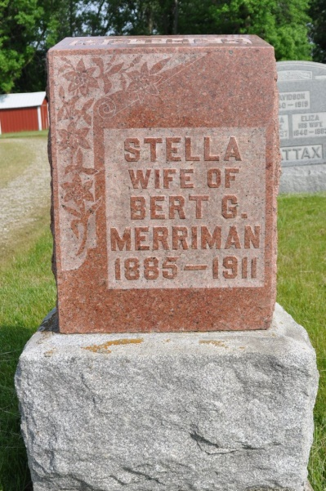
Photo by Deb Curry

Mrs. Stella Merriman, wife of Bert Merriman, of Monroe Township, died Sunday from tuberculosis; aged 26 years. Both Mr. and Mrs. Merriman were born in this county (Adams) and spent their early days here. Husband obtained work in Dayton, Ohio. Deceased contracted tuberculosis in Dayton in February. Her health did not improve and it was thought best that they return to their former home here, arriving in April. Deceased was born Stella Smith, daughter of Barclay Smith, who resides in Berne. Her mother died some time ago. Deceased born 26 June 1885.
Survivors include husband, father, four children - Harry, 7 years, June, Beatrice and Anna, eight months. Also surviving: sisters and brothers - Mrs. Nellie Ray, Mrs. Roxie Lahman, Ransom B. Smith, Harley B. Smith, Charles H. Smith. Mr. Merriman is a son of J. W. Merriman of this city. Funeral held Wednesday at the South Salem M. E. Church.

Willshire Herald Newspaper Extractions by Kathryn Case Moore
From: Decatur Daily Democrat, Adams County, IN; Thursday, August 31, 1911, page 8

*****
NORTH MONROE, Aug. 30, 1911 - The funeral of Mrs. Bert Merryman, a victim of the dread tuberculosis, was held today at Salem church.
At her home one mile west of Salem occurred the death of Mrs. Burt Merriman Sunday. The young lady, who was about twenty-five years of age, leaves a husband and four children. Mrs. Merriman had been suffering for some time with tuberculosis and this was the cause of her death. She is the daughter of Mr. and Mrs. Barkley Smith, of Berne.
Berne Witness, Adams County, Indiana; Friday, Sept. 1, 1911
Contributed by Karin King

