Philip Martz
February 8, 1831 – November 15, 1906

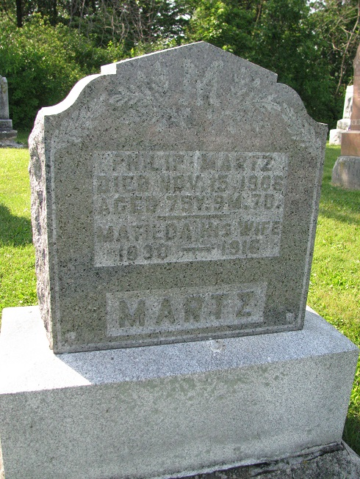
Photos by PLS

PHILLIP MARTZ DIED SUDDENLY
Was An Aged Citizen of Blue Creek Township
Phillip Martz, one of the wealthiest and best known citizens of Blue Creek Township, died suddenly yesterday morning at his home near Steele. He was seventy-eight years old and had enjoyed good health for one of his years.
He leaves only the aged wife.
The funeral services will be held tomorrow morning at eleven o'clock from the South Salem Church at Steele.

Decatur Democrat, Adams County, IN; Thursday, November 22, 1906

Contributed by Karin King

