Marcia L. (Walters) Manley
March 18, 1937 – November 25, 2004

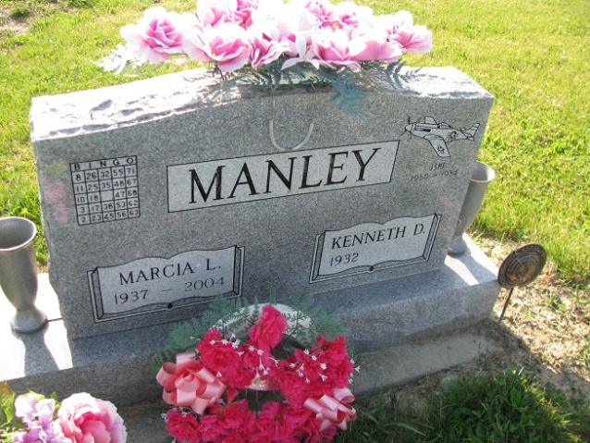
Photos by PLS

Marcia L. Manley, 67, died unexpectedly Thursday, November 25, 2004, 2:30 pm at Lutheran Hospital in Fort Wayne following complications resulting from heart surgery. Born March 18, 1937, in Ohio City, Ohio, she was the daughter of the late Hugh Walters and Velma Shinnaberry. She married Kenneth D. Manley, September 29, 1956; he survives.
She retired from Lincoln National Life Insurance Co. after 27 years of service and was employed part-time with Scott’s Grocery in Decatur. She was a member of the Women of the Moose in Decatur.
Surviving in addition to her husband of Decatur, are sons, James (Tracey) Manley and Jeffrey Manley, both of Decatur; daughter, Mrs. Robert (Debra) Blythe of Decatur; brothers, Richard “Bucky” (Francis) Walters of Hamilton; Ronald (Connie) Walters of Van Wert; Jerry (Bonnie) Walters of West Liberty, Ohio; and sister, Mrs. Richard (Carolyn “Cookie”) Brandt of New Haven; four grandchildren; four step-grandchildren; and two step great-great grandchildren. She was preceded in death by a sister, Dorothy Hart, a brother, Bill Walters and granddaughter, Jessica R. Manley, April 14, 2003.
Service is 1 pm Monday at Zwick & Jahn Funeral Home, Decatur with visitation from noon to 3 and from 4 to 7 pm Sunday. Burial at Tricker Cemetery in rural Monroe.
Preferred memorials to Mooseheart and Adams County Community Foundation – Heart Fund.

Fort Wayne News-Sentinel (IN); November 27, 2004, Page 2L

