Katherine M. Jones
September 2, 1930 – July 31, 1991

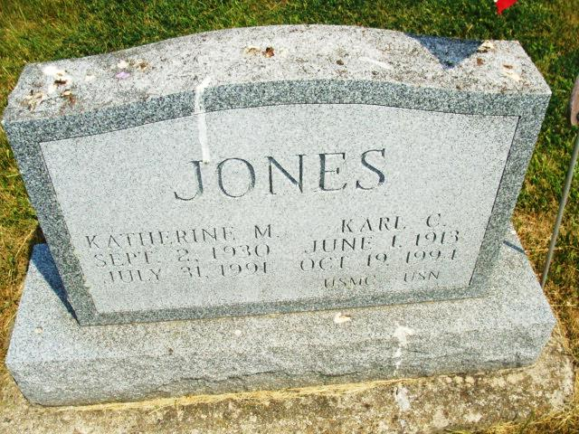
Photo by Alicia Kneuss

Graveside service 10:30 am tomorrow in Tricker Cemetery, Monroe.

Fort Wayne News-Sentinel (IN); August 7, 1991, Page 3A

*****

Adams Public Library System (Decatur, IN) online obit abstracts
Publication: Decatur Daily Democrat; Date: August 6, 1991
Title: Jones, Katherine; Subject: Obituaries – J – 1990-1999
Abstract: Age 60
Died: Wednesday, July 31, 1991
Married: Karl C. Jones
Notes: DPL Scrapbook 8-228-1

