Karl C. Jones
June 1, 1913 – October 19, 1994

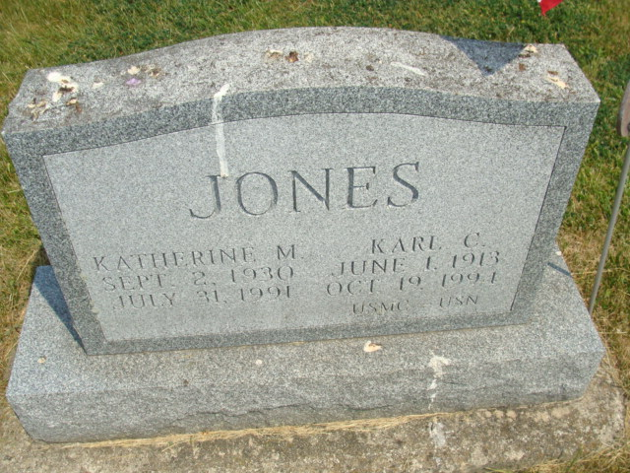
Photo by Alicia Kneuss

Karl C. Jones, 81, formerly of Adams County, died Wednesday at his home in Cupertino, California. He was a retired maintenance engineer with the Veterans Administration.
Surviving are a daughter, Karen Jones of Cupertino; sons, Karl C. Jr. of Huntington Valley, Pa., and Kenneth of Colorado Springs, Colo.; brothers, Glen L. Jones of rural Berne and Harvey L. Jones of rural Decatur; sisters, Martha Von Guten of Berne, Doris E. Ray of Marion and Mary Ann Bebout of rural Decatur.
Graveside services are 10 am Tuesday in Tricker Cemetery in Monroe.

Fort Wayne News-Sentinel (IN); October 22, 1994, Page 10A

