Josephus Johnson
December 3, 1827 – January 12, 1903

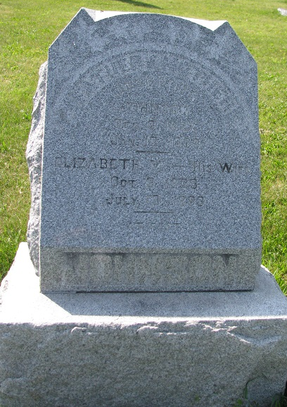
Photo by PLS

Josephus Johnson was born in Logan County, Ohio, December 3, 1827 and died at Richmond January 12, 1903; aged 75 years, 1 month and 9 days. He moved with his father’s family to Adams County when 9 years old. He was married to Mary Elizabeth Holmes in 1850.
To this union were born two sons, Thomas, who resides in Willshire, Ohio and J. G. Johnson of near Portland. He leaves to mourn his death, two brothers and two sisters. One brother and one sister live in Indiana and one brother and remaining sister in California.
The funeral services were held in the M. E. Church at 1 o’clock Wednesday, January 14, 1903, conducted by Rev. H. Kohn and interment was in Blue Creek Cemetery in Adams County.

Portland Weekly Commercial, Jay County, IN; February 9, 1903

Contributed by Jim Cox

