Gladys F. (Dague) Gibson
January 25, 1908 – December 3, 1992

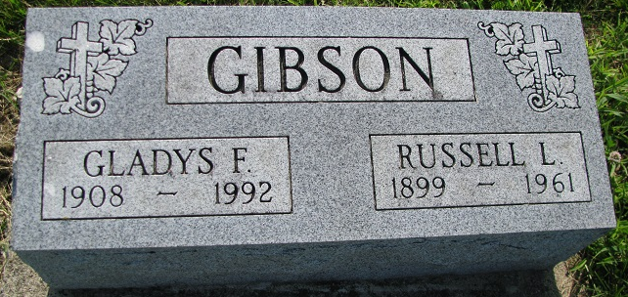
Photos by PLS

Gladys F. Gibson, 84, Hoagland, widow of Russell Gibson, died this morning in the extended care unit of Adams County Memorial Hospital. Funeral arrangements are pending at Zwick-Sefton and Jahn Funeral Home.

Decatur Daily Democrat, Adams County, IN
Thursday, December 3, 1992

*****

Gladys F. Gibson, 84, Hoagland, died Thursday in the extended care unit of Adams County Memorial Hospital after having been a patient there the past month. The Decatur native married Russell L. Gibson in 1926; he died in 1961.

Decatur Daily Democrat
Friday, December 4, 1992

Both contributed by Karin King

