Esther Faye (Manley) Cook
January 6, 1928 – January 12, 2000

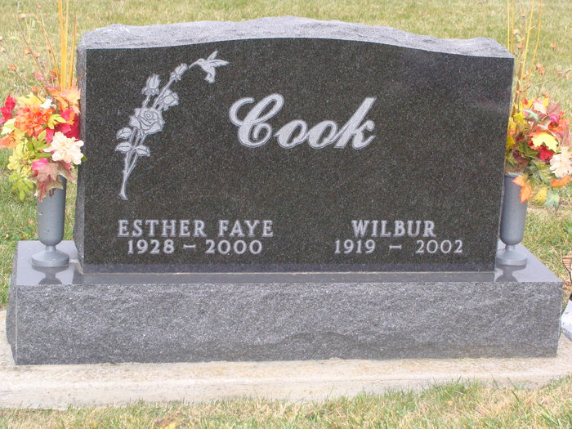
Photo by Alicia Kneuss

Esther Faye Manley Cook - 1928-2000

Esther Faye Cook, 7, of rural Decatur, a homemaker, died Wednesday, January 12, 2000, at St Joseph Hospital Fort Wayne, Indiana.
The Adams County native was a member of Mount Zion United Brethren in Christ Church in Bobo, Ladies Aid of the Church and Ladies Missionary of the Church.
Surviving are her husband of 53 years, Wilbur; sons Delane, Ronnie and Jeffrey, all of Decatur, and Rodney of Monroe; daughters Nancy Isch of Decatur, Connie Myers of Monroe, Julie Burkhart of Willshire, Ohio and Jane Gremaux of Decatur; sisters Edna Manley of Berne, Mildred Wolfe of Pleasant Mills, Mable Miller Willshire, Ohio, Velma Penrod of Bluffton, Lois Agner Lepsic, Ohio, and Marcile King of Decatur; brothers Glen, Richard, Kenneth and Lester Manley, all of Decatur; 18 grandchildren; and 11 great-grandchildren. She was preceded in death by two sisters.
Services are 2 p.m. Sunday at Zwick & Jahn Funeral Home, Decatur, with calling two hours before services. Calling also from 2 to 5 and 6 to 8 p.m. Saturday at funeral home. Burial will be in Tricker Cemetery, Monroe.
Memorials are to Mount Zion United Brethern in Christ Church and the Diabetes Association.
Information provided by Zwick & Jahn Funeral Home, Decatur, 1-260-74-9164.

News-Sentinel, The (Fort Wayne, In) - January 14, 2000

