Martha Ellen (Gause) Case
April 20, 1853 – April 25, 1911

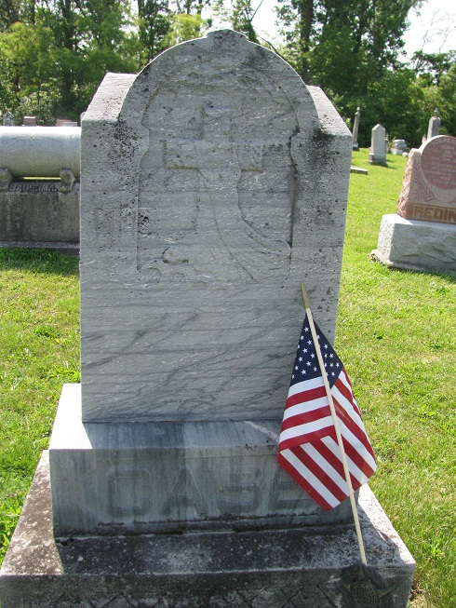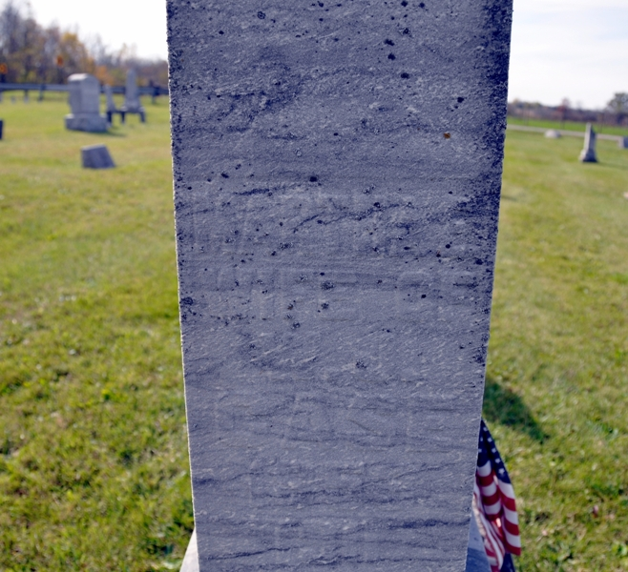
Photo by PLS Photo by Deb Curry

Martha Ellen Case was born near Willshire, Ohio, April 20, 1853, and died at the home of her daughter, Mrs. John Ainsworth, near Van Wert, April 25, 1911, of paralysis, aged 58 years and five days. She was united in marriage to William J. Case, in 1861 (sic). To this union thirteen children were born - eight daughters and five sons. The husband and father, three daughters and one son, preceded her in death. The survivors are Mrs. John Ainsworth, Van Wert; Mrs. Maggie Garwood, Mercer County; Nettie, residing at Edinburg, Ind.; Bertha, at Berne, Ind.; Lulu, at Muncie, Ind.; Lan and Robert, at Monroe, Ind.; Frank, at Casey, Ill.; and Earl, at Willshire. About thirty-five years ago deceased was converted and joined the U. B. church of which she was a faithful member up to the time of her death. She had been a great sufferer for more than two years, but amidst it all she was always patient and reconciled to her fate, anxious for the time to come when she could go home and be forever at rest.
Besides the children she leaves two brothers, Ohio and Enoch Gause; one sister, Mrs. Jane Miller; twenty-one grandchildren and a host of other friends to mourn her departure.
Funeral services will be conducted by Rev. H. Kohn, at 1 o'clock this afternoon, at Salem. Interment in the Tricker cemetery.

Willshire Herald, Van Wert County, Ohio; Thursday, April 27, 1911

