Rebecca Jane (Gilpin) Campbell-Ray
October 4, 1824 – August 10, 1909
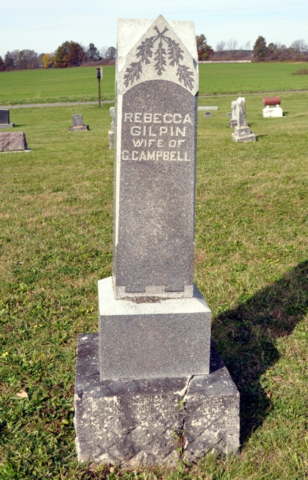
Photo by Deb Curry
(Handwritten: Aug. 12, 1909)
Rebecca Jane Ray died at her home near Salem, Tuesday, aged 84 years, 10 months and 7 days. The cause of her death was apoplexy. The funeral will be held at Salem this morning at ten o'clock.
Willshire Herald, Van Wert County, Ohio
Contributed by Karin King
*****
The obituary of Rebecca's second husband, John W. Ray, states the following regarding Rebecca:
Mrs. [Mercy] Ray died January 19, 1880, and January 24, 1884, Mr. Ray married Rebecca Campbell, widow of George Campbell, and daughter of Elijah and Etha(sic) Gilpin, early settlers of Adams County. She had seven children by her first marriage - Atha A., wife of John Beatty; Sarah J., deceased; William, George, Elijah; Cynthia, wife of Freeman Miller, and Roxana, deceased.

