Dolly M. (Richard) Burkhart
August 5, 1896 – September 13, 1988

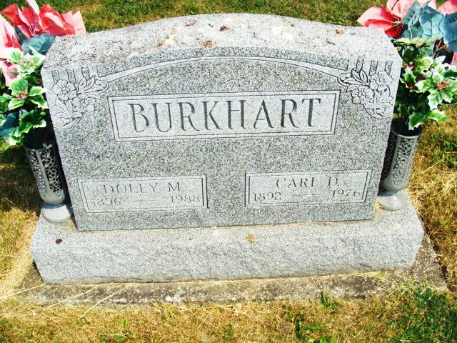
Photo by Alicia Kneuss

Dolly Burkhart, 92, a resident of Decatur since 1976 and formerly of Pleasant Mills, died at 7:20 p.m. Tuesday in Lakeside Manor.
She was employed in the Pleasant Mills School cafeteria for many years.
Born in Adams County on Aug. 5, 1896, she was the daughter of John and Maggie Dague Richard, and was married March 24, 1915 to Carl D. Burkhart; he died Sept. 22, 1976.
Survivors include 4 children: Wilbur L. Burkhart, route 5, Decatur; Mrs. Mildred Halberstadt, Richmond; Richard E. Burkhart and Gordon W. "Bill" Burkhart, both of Decatur; and 14 grandchildren. Two sons, Robert C. and Glen Eugene, and two sisters are deceased.
Services will be held at 1 p.m. Friday at Zwick-Sefton & Jahn Funeral Home, Rev. Joseph Gibson officiating. Burial will be in Tricker Cemetery. Friends may call at the funeral home from 2-9 Thursday.
Decatur Daily Democrat, Adams County, Indiana; Wed, Sep 14, 1988
Contributed by Karin King

