Joseph Parker Brookhart
March 21, 1886 – January 17, 1975

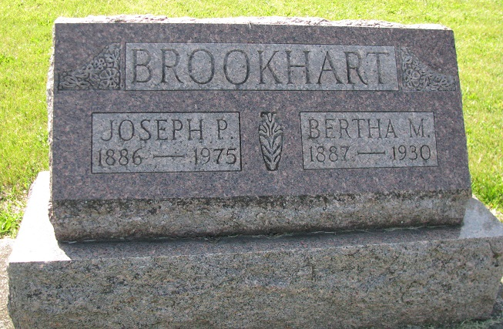
Photo by PLS

Joseph P. Brookhart, 88, of route 5, Decatur, a retired farmer and construction worker who retired 20 years ago, died at 12:30 a.m. this morning at the Adams county memorial hospital, where he had been a patient two days. He had been in ill health for several years.
He was a member of the Washington St. Church of Christ.
Born in Mercer county, O., on March 21, 1886, he was the son of Gilbert and Manerva Grimm-Brookhart, and was married to Bertha Ferguson who died in 1930. He married Mamie Teeple on August 24, 1935 and she survives.
Other survivors include one daughter, Mrs. Max (Nellwyn) Trujillo of Vallecitos, N. M.; one son, G. D. (Gilbert) Brookhart of Fort Wayne; two sisters, Mrs. Alice Hayes of Mendon, O.; Mrs. Ethel Cook of Wapakoneta, O.; four grandchildren and one greatgrandchild. One daughter, Ione, preceded him in death.
Funeral services will be held at 1:30 p.m. Monday at the Zwick funeral home, with Rev. Robert Bernhardt officiating. Burial will be in the Tricker cemetery. Friends may call at the funeral home after 7 p.m. Saturday.

Decatur Daily Democrat, Adams Co, IN; Friday, January 17, 1975

