Paul William Brehm
September 18, 1915 – July 22, 1976

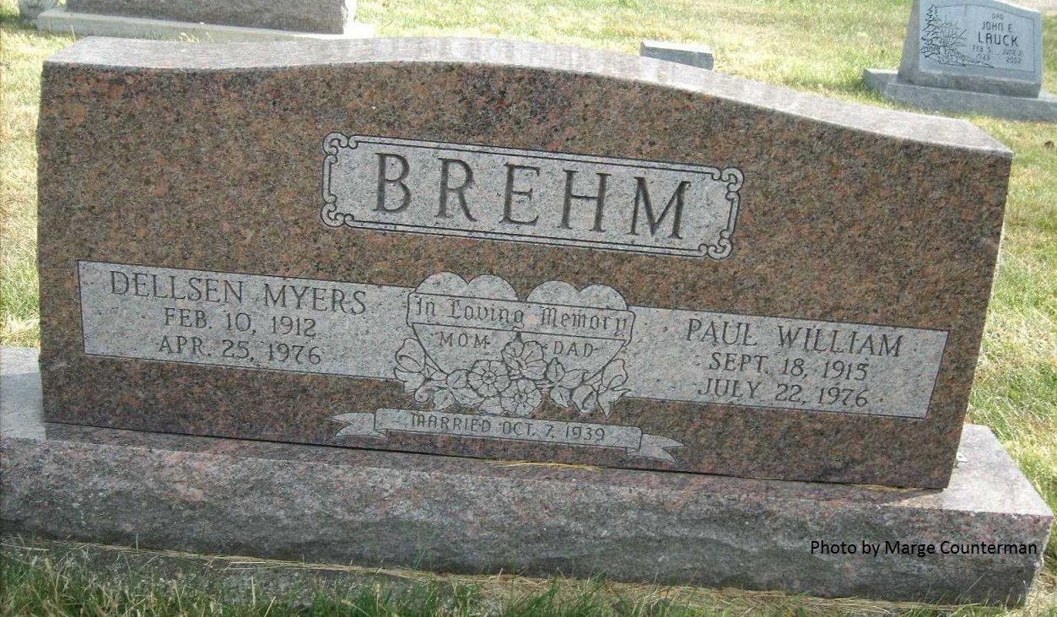

Adams Public Library System (Decatur, IN) online obit abstracts
Publication: Decatur Daily Democrat; Date: 22 JUL 1976, p. 5
Title: Brehm, Paul W.
Subject: Obituaries -- B -- 1970-1979
Abstract: Age 60
Born: September 18,1915
Died: Thursday, July 22,1976
Married: Dellsen Myers on October 7,1939
Parents: Fred & Leota Kanorr Brehm
Notes: DPL Scrapbook 4-7-5

