Dale F. Baumgartner
February 27, 1924 – May 20, 1993

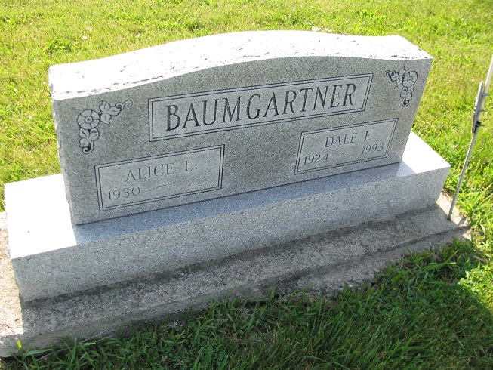
Photo by PLS

DALE F. BAUMGARTNER, 69, of Decatur died yesterday in St. Rita's Medical Center, Lima, Ohio. The Chattanooga, Ohio, native retired from Andrews Saw Mill after 35 years and was a veteran of World War II. Surviving are his wife, Alice, and a brother, Ralph W. of Chattanooga. Services are 1 p.m. tomorrow in Zwick, Sefton & Jahn Funeral Home, Decatur, where calling is 6 to 8 p.m. today. Burial will be with military honors in Tricker Cemetery, Monroe. Preferred memorials are gifts to charity.

News-Sentinel, The (Fort Wayne, IN) - Friday, May 21, 1993

Contributed by Jane Edson

